**CENWP-OD-D 6/13/2023**

**MEMORANDUM FOR THE RECORD 23TDA03**

**SUBJECT: Gatewell Mortalities**

On 6/13/23 during a gatewell inspection, 9 subyearling mortalities were observed in the intake gatewells. Five of these were in unit 16, presently out of service and not dewatered. It was noted previously that were approximately 100 subyearlings in unit 16 upon shutdown May 22. That decreased to about 35 plus the 9 morts by June 13.

1. Species –Appear to be subyearling chinook
2. Origin –NA
3. Length –NA
4. Marks and tags –NA
5. Marks and Injuries found on carcass –Not visible from distance
6. Cause and Time of Death –unknown
7. Future and Preventative Measures –These areas normally accumulate small numbers of juveniles during passage season, despite no diversion screens. Orifices associated with most of these units have been closed permanently per FPOM agreement in the mid 2000s. Fish must sound down to exit the gatewell.

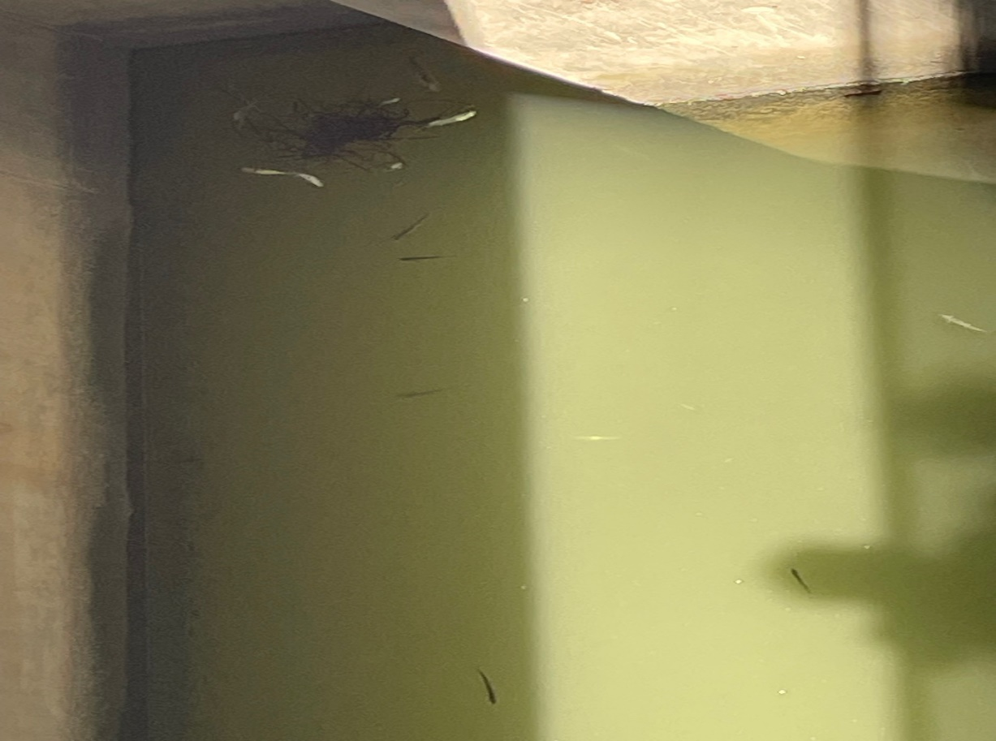

Sincerely,

Project Fisheries